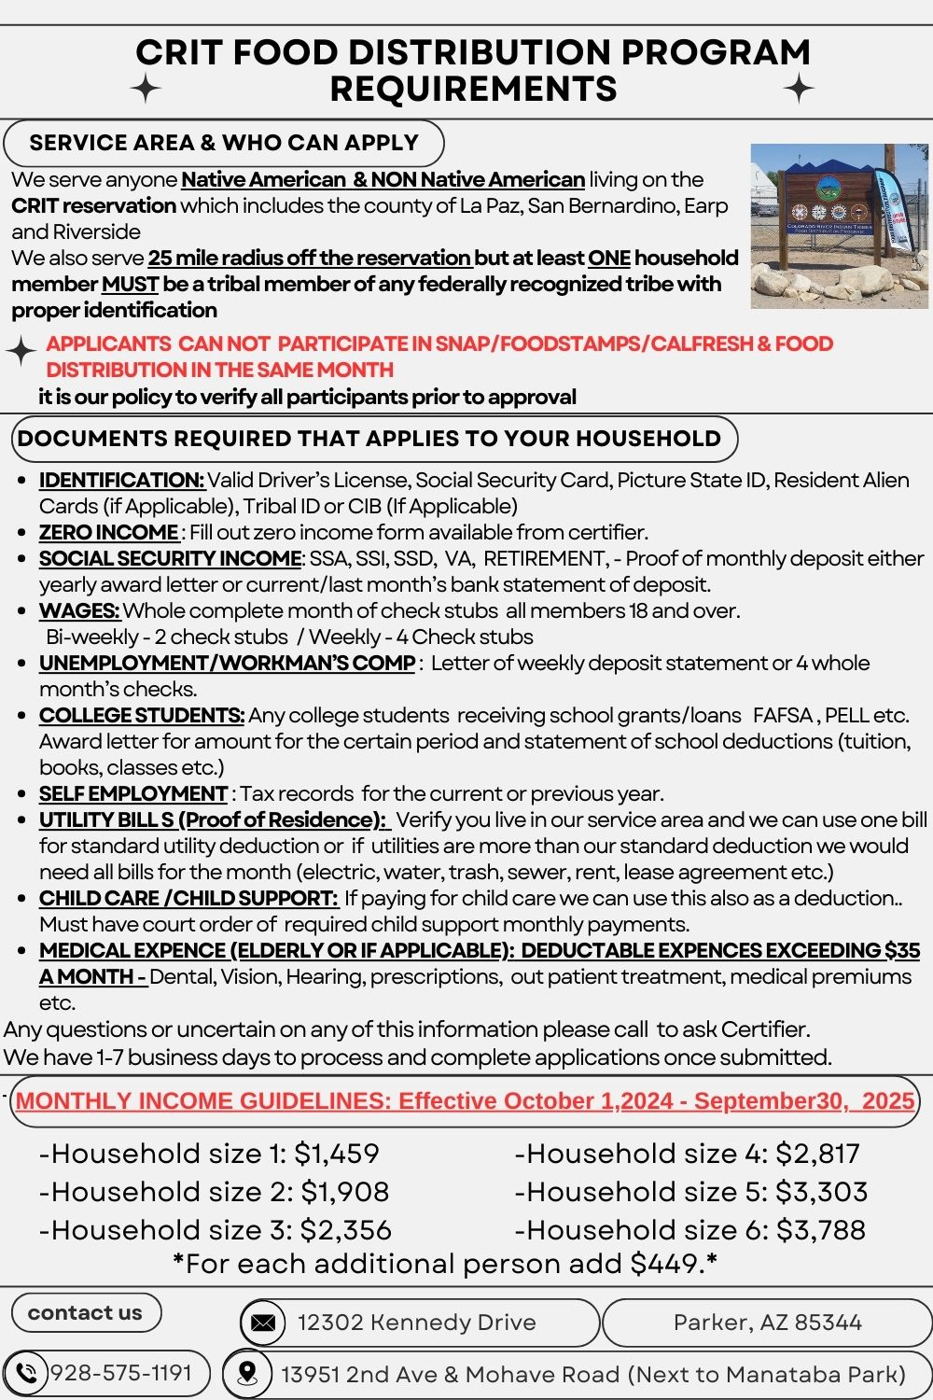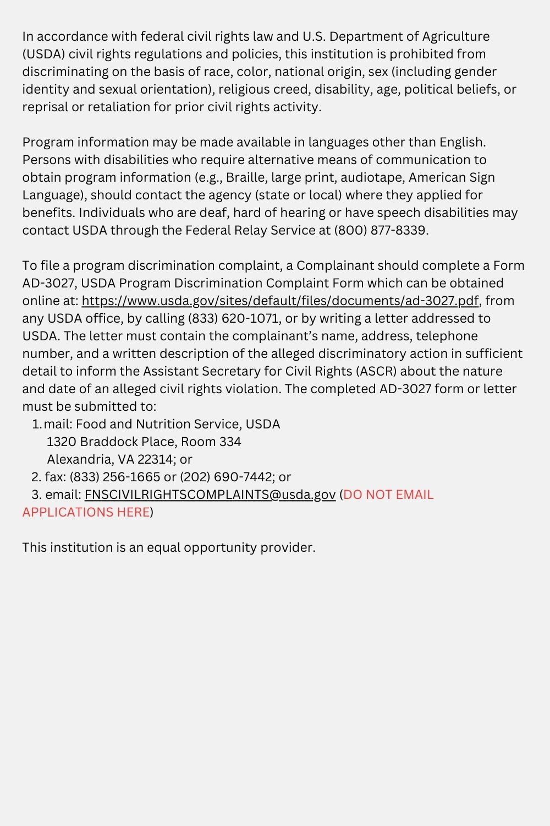



***APPLICATION***

**CRIT DHS** **FOOD DISTRIBUTION PROGRAM**

Physical; 13951 2nd Ave & Mohave (Next to Manataba Park)

Mailing: 12302 Kennedy Drive, Parker, Arizona 85344

Telephone Number: (928) 575-1191

***OFFICIAL USE ONLY***

**Date Application Received FDP___________________**

**______New Application**

**______Re Apply**

**______Recertification**

**____ Update Application**



Complete the following information. If you **refuse to cooperate /provide verification,** your application will be denied. You must provide proof/verification of all income and allowable deductions.

|  |  |  |  |
| --- | --- | --- | --- |
| **Name** (**Head of Household**): |  | **County: Circle ONE** | La Paz / San Bernardino / Riverside |
| **Mailing Address:** |  | **Household Size:** |  |
| **City/State/Zip Code:** |  | **Telephone No.:** |  |
| **Physical Address:** |  | **Message/Cell Phone:**  **1** |  |

**HOUSEHOLD MEMBERS:** Complete the following for **each** member of your household. Your household means yourself and the people who live with you. List your name first. (Attach a separate sheet if you need to list additional household members.)

|  |  |  |  |
| --- | --- | --- | --- |
| **NAME(S) OF ALL HOUSEHOLD MEMBERS**  *(Last, First, Middle Initial).* **Please Print**. | **RELATIONSHIP TO HEAD**  **OF HOUSEHOLD**  *(Self, spouse, daughter, son, cousin etc.)* | **DATE OF BIRTH** | **SOCIAL SECURITY #** |
| 1. |  |  |  |
| 2. |  |  |  |
| 3. |  |  |  |
| 4. |  |  |  |
| 5. |  |  |  |
| 6. |  |  |  |
| 7 |  |  |  |
| 8. |  |  |  |

*Are you or anyone in your household currently receiving SNAP benefits? 🞏 Yes 🞏 No If yes, list names: ___________________________

*Have you or anyone in your household recently applied for SNAP benefits? 🞏 Yes 🞏 No If yes, list names: __________________________

Have you or anyone in your household been disqualified from the Supplemental Nutrition Assistance Program (SNAP) for an intentional program violation? 🞏 Yes 🞏 No**.** If yes, list name(s): _______________________________________________________________

**INCOME (EARNED & UNEARNED): 🞏 Yes 🞏** **No** List income from all sources for **each** household member including wages, social security, SSI, SSD, TANF, general/public assistance, foster care payments, unemployment or worker’s compensation, child support, alimony, pensions, Veteran’s benefits, per capita payments from gambling enterprises, work/training allowances, etc.

**Verification of income is required for all household members (pay check stubs, award letters, etc.)**. **Households with earned income must provide a full month’s wage statements.** Attach a separate sheet, if you need to list additional household members.

|  |  |  |  |  |
| --- | --- | --- | --- | --- |
| **HOUSEHOLD MEMBER** | **Employer**/  **SOURCE OF INCOME** | **TYPE OF INCOME (Wages, Social Security, TANF, Child Support, etc.)** | **GROSS AMOUNT** | **HOW OFTEN PAID**  **Monthly, Bi-weekly, Weekly** |
|  |  |  |  |  |
|  |  |  |  |  |
|  |  |  |  |  |
|  |  |  |  |  |

**SELF-EMPLOYMENT INCOME:** Are there any members in your household who are self-employed? **🞏 Yes 🞏** **No** If yes, complete the following section.Payment from rental property, roomers, boarders, farming, ranching, and/or operating your own business is considered to be self-employment. Please provide a copy of last year’s Federal Income Tax form (1040, Schedules F, C, E, if applicable, or other proof of self-employment costs and income (current books showing income and expenses).

|  |  |  |  |
| --- | --- | --- | --- |
| **HOUSEHOLD MEMBER** | **TYPE OF BUSINESS**  **(Farm, Ranch, Rental, Day care, etc)** | **OCCUPATION** | **Is your self-employment the primary source of income for meeting your living expenses?** |
|  |  |  |  |
|  |  |  |  |

**STUDENTS**: Are there any students in your household who receive education grants, scholarships or loans? **🞏 Yes 🞏 No**   
If yes, complete the following section. Please provide verification.

|  |  |  |  |  |
| --- | --- | --- | --- | --- |
| **HOUSEHOLD MEMBER** | **AMOUNT OF LOAN/GRANT** | **PERIOD OF TIME FUNDS INTENDED TO COVER** | **TYPE OF PAYMENT**  **(Pell Grant, Student Loan, BIA)** | **Amount Used to pay Tuition/School Fees/Other Rel. Exp.** |
|  |  |  |  |  |
|  |  |  |  |  |

**ALLOWABLE DEDUCTIONS [Please provide verification]:**

**STANDARD SHELTER/UTILITY EXPENSE:** Does anyone in your household pay, on a monthly basis, at least one shelter/utility expense? **🞏 Yes 🞏 No**

If yes, type of shelter/utility expense paid monthly: **🞏 RENT 🞏 WATER/ELECTRIC 🞏CELL/TELEPHONE**

**🞏 OTHER:** **_____________________________________________________________________________________________________**

**DEPENDENT CARE:** Does anyone in your household pay for the care of a child or other dependent when necessary for a household member to accept or continue employment or to attend training or pursue education which is preparatory to employment? **🞏 Yes 🞏 No**

If yes, name and address of person providing care: _________

Amount Paid: $ How often paid (weekly, monthly, etc.) _______________

**CHILD SUPPORT:** Does anyone pay court ordered child support for a non-household member? **🞏 Yes 🞏 No**

If yes, complete the following: Amount ordered to pay: $ ____Amount actually paid: $_________________

**EXCESS MEDICAL EXPENSES:** Anyone in your household elderly and/or disabled? **🞏 Yes 🞏 No**

If yes, complete the following: **Monthly total of medical expenses,** excluding special diets: $________________________

**AUTHORIZED REPRESENTATIVE:**  To authorize someone outside your household to act on your behalf and/or pick up your food, complete this section.

|  |  |  |
| --- | --- | --- |
| **NAME(S)** | **ADDRESS** | **TELEPHONE NUMBER** |
|  |  |  |
|  |  |  |
|  |  |  |

**RACIAL/ETHNIC DATA COLLECTION:** This information is voluntary. If you do not provide this information, it will not affect your eligibility.

**1. What is your ethnic category?** **🞏** Hispanic or Latino **or** **🞏** Not Hispanic or Latino

**2. What is your race?** **🞏** American Indian or Alaskan Native **🞏** Asian **🞏**Black or African American

**🞏** Native Hawaiian or Other Pacific Islander **🞏** White

**\*Please read the following before signing application\***

**FAIR HEARING:** If you disagree with any action taken on your case, you or your representative have the right to request a fair hearing. You may request a fair hearing in writing or orally. If you request a fair hearing, your case may be presented by a household member or representative, such as a legal counsel, a relative, a friend or other spokesperson.

**PENALTY WARNING:**  If your household receives USDA foods, it must follow the rules below. Failure to comply with these rules may result in a monetary claim being filed against the household and /or disqualification from participation in the Food Distribution Program.

1. **Do not make false or misleading statements, misrepresent, conceal, or withhold facts regarding income, resources, household size, and/or participation in the Supplemental Nutrition Assistance Program (SNAP) in order to obtain Food Distribution Program benefits which your household is not entitled to receive.**
2. **Do not misuse (e.g., trade or sell) USDA foods.**
3. **Do not participate simultaneously in the Supplemental Nutrition Assistance Program (SNAP) and the Food Distribution Program.**

**INTENTIONAL PROGRAM VIOLATION (IPV) PENALTIES:** If you or any member of your household knowingly and willing violates the rules above it is considered an Intentional Program Violation (IPV). Household members determined to have committed an IPV will be ineligible to participate in the Food Distribution Program for a period of 12 months for the first violation, for a period of 24 months for the second violation; and permanently for the third violation. Individual(s) committing an IPV may be referred to authorities for prosecution.

**AUTHORIZATION:** I authorize the release of any necessary information or forms to the Food Distribution Office from individuals, businesses, schools, banking institutions, Federal/State/Tribal agencies needed to determine/verify my eligibility. I understand that this information will be used only for the purpose of helping to document my eligibility for Food Distribution benefits. This authorization is good for 12 months from the date signed or until revoked by me in writing.

**CERTIFICATION STATEMENT:** I certify that I have read this application and that the information contained in it is true and correct to the best of my knowledge. I understand that I must comply with Program rules and provide additional documentation if required, and that falsification of information on this form may be grounds for disqualification and/or claim action. **I further understand that I must report within ten (10) calendar days after the change becomes known the following changes: a change in household size or composition; an increase in gross monthly income of more than $100;** a change in residence/address; when the household no longer incurs a shelter pr utility expense; or a change in the legal obligation to pay child support.

**APPLICANT’S SIGNATURE: ____________________________________________** **DATE: _________________________________**

**In accordance with federal civil rights law and U.S. Department of Agriculture (USDA) civil rights regulations and policies, this institution is prohibited from discriminating on the basis of race, color, national origin, sex (including gender identity and sexual orientation), religious creed, disability, age, political beliefs, or reprisal or retaliation for prior civil rights activity.**

**Program information may be made available in languages other than English.  Persons with disabilities who require alternative means of communication to obtain program information (e.g., Braille, large print, audiotape, American Sign Language), should contact the agency (state or local) where they applied for benefits. Individuals who are deaf, hard of hearing or have speech disabilities may contact USDA through the Federal Relay Service at (800) 877-8339.**

**To file a program discrimination complaint, a Complainant should complete a Form AD-3027, USDA Program Discrimination Complaint Form which can be obtained online at:**[**https://www.usda.gov/sites/default/files/documents/ad-3027.pdf**](https://www.usda.gov/sites/default/files/documents/ad-3027.pdf)**, from any USDA office, by calling (833) 620-1071, or by writing a letter addressed to USDA. The letter must contain the complainant’s name, address, telephone number, and a written description of the alleged discriminatory action in sufficient detail to inform the Assistant Secretary for Civil Rights (ASCR) about the nature and date of an alleged civil rights violation. The completed AD-3027 form or letter must be submitted to:**

1. **mail:  
   Food and Nutrition Service, USDA  
   1320 Braddock Place, Room 334  
   Alexandria, VA 22314; or**
2. **fax:  
   (833) 256-1665 or (202) 690-7442; or**
3. **email:**[**FNSCIVILRIGHTSCOMPLAINTS@usda.gov**](mailto:FNSCivilRightsComplaints@usda.gov) **(DO NOT EMAIL APPLICATION TO THIS EMAIL)**

**This institution is an equal opportunity provider.**

FDPIR Application Form, Revised 10/2024-JJ